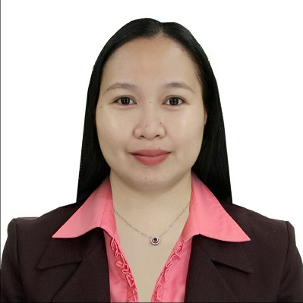

**ADRELYN C. TEJANO, LPT**

**Address: Afusing Daga, Alcala, Cagayan**

**Mobile Number: 0935-233-2473**

**Email Address:** [adrelyntejano@gmail.com](mailto:adrelyntejano@gmail.com)

**CAREER OBJECTIVES:**

* To seek a suitable job in which I can employ my skills and knowledge to enhance my skills and abilities in my chosen field.
* To serve and reach out people through my work and enrich my personal and learning horizon through dedicated service and gain knowledge from people whom I interact with.
* To render service beyond your company.
* To better understand myself more as being attuned in the field I chose.

**PERSONAL PROFILE:**

Name: Adrelyn C. Tejano

Age: 30

Height: 153 cm

Weight: 55 kg

Address: Afusing Daga, Alcala, Cagayan

Birthdate: October 13, 1993

Civil Status: Single

Religion: Roman Catholic

**WORK EXPERIENCE:**

**SUPPLY STAFF**

Medical Colleges of Northern Philippines and

International School of Asia and the Pacific

Alimannao Hills, Peñablanca, Cagayan 3502

November 09, 2022 – July 31, 2024

**ASSISTANT JAPANESE LANGUAGE INSTRUCTOR**

Medical Colleges of Northern Philippines and

International School of Asia and the Pacific

Alimannao Hills, Peñablanca, Cagayan 3502

November 27, 2017 – July 06, 2020

**ASSEMBLY OPERATOR**

International Wiring Systems Philippines Corporation

Luisita Industrial Park, San Miguel, Tarlac City 2301

May 06, 2015 – April 16, 2016

**EDUCATIONAL BACKGROUND:**

**BACHELOR OF SCIENCE IN INFORMATION TECHNOLOGY**

International School of Asia and the Pacific

Alimannao Hills, Peñablanca, Cagayan 3502

Batch 2010 – 2014

**CAREGIVING NCII-TESDA**

International School of Asia and the Pacific

Alimannao Hills, Peñablanca, Cagayan 3502

Batch 2016 – 2017

**CERTIFICATION IN PROFESSIONAL EDUCATION** (EARNING UNITS)

International School of Asia and the Pacific

Alimannao Hills, Peñablanca, Cagayan 3502

Batch 2018

**CHARACTER REFERENCE:**

**GAY V. HULLANA, MBA**

PhilHealth Clerk

Dr. Ronald P. Guzman Medical Center

0977-621-2191

**KRISTETA MANG-EL**

Assistant Japanese Language Instructor

Medical Colleges of Northern Philippines and

International School of Asia and the Pacific

0998-235-1847

**AGUS-ANN AHHUY, LPT**

Secretary

Medical Colleges of Northern Philippines and

International School of Asia and the Pacific

0955-407-2112

*I hereby certify that the above information is true and correct to the best of knowledge and belief.*

**ADRELYN C. TEJANO, LPT**

Applicant