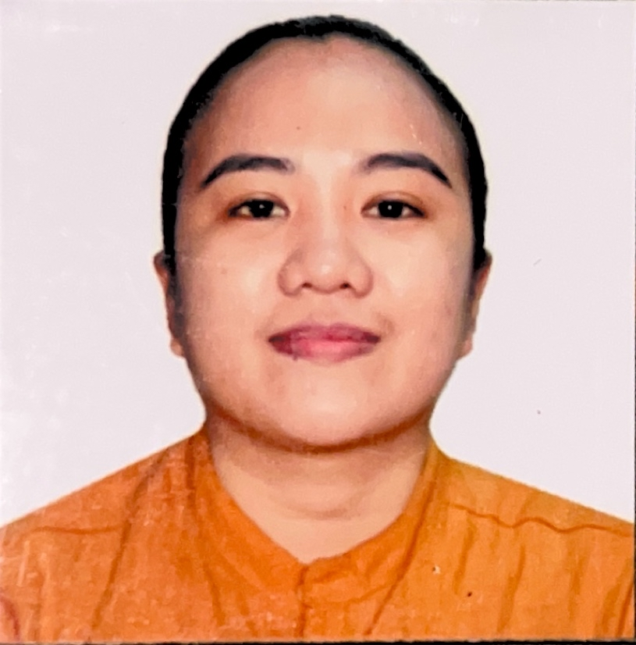

**EZRAH JOY DALUNES OLLADAS**

BS Information System Graduate

Prk. Bolinao Brgy. 1 Bacolod City

Email Address: olladasjoyezrah@gmail.com

Contact No. +63 9100-280-696

**OBJECTIVES**

A hard working, flexible and responsible employee seeking for job in business industry to utilize my skills which were developed through past work experiences in the field of business process outsourcing and education. I am keen to details, has excellent customer service approach and a strong drive to complete my task correctly and timely.

**PERSONAL INFORMATION**

Home Address : Purok Bolinao Brgy. 1 Bacolod City

Date of Birth : January 22, 1998

Age : 26 Years Old

Place of Birth : Bacolod City

Gender : Female

Place of Birth : Purok Bolinao, Brgy.1 Bacolod City

Height : 5’4

Weight : 70Kg

Civil Status : Single

Religion : Christian

Languages Spoken : English, Tagalog

Citizenship : Filipino

Father’s Name : Benjie F. Olladas

Mother’s Name : Jenalyn D. Olladas

**SPECIAL SKILLS AND QUALIFICATION**

* Able to speak.read,and write in English
* Computer Literacy. Proficient in MS Word, MS Excel and MS Power point, Internet, cooking and cake decorating
* Customer service
* Food preparation
* Time management
* Relationship cultivation
* Enjoying working as part of a team
* Work environment

**EDUCATIONAL ATTAINMENT**

**TERTIARY** : Bachelor of Science in Information System

Carlos Hilado Memorial State College

Alijis Bacolod City

(S.Y. 2017-2018)

**SECONDARY** : Domingo Lacson National High School

Brgy. Banago, Bacolod City

(S.Y. 2013-2014)

**PRIMARY**  : Andres Bonifacio Elementary School

Brgy. 3, Bacolod City

(S.Y. 2010-2011)

**WORKING EXPERIENCE**

On-the-job Trainee

Land Transportation Office (LTO)

Bacolod City Negros Occidental

November 10,2017- March 9, 2018

Jollibee Food Corporation

Service Crew

Bacolod City Negros Occidental

June 18, 2018-2022

Jollibee Food Corporation

Assistant Restaurant Manager

March 28, 2022 – Present

**REFERRENCES**

**Chiney O. Serato**

+639302161019

Manager

Gaisano City

**Chessa Celiz**

+639121495294

Manager

Robinson Bacolod

**Louella Dela Cruz**

+639307666547

HR Manager Ponce Group of Company